**Azure databricks coding challenge Q-3**

**3. AZURE DATA FACTORY:**

Azure data factory is a cloud-based integration service that allows user to create data-driven workflow in the cloud for orchestrating and automating data movement and data transformations.

Azure data factory does not store any data itself.

**COPY ACTIVITY IN AZURE DATA FACTORY:**

The copy activity in azure data factory copies data from a source data store to a sink data store. Azure supports various data stores such as source or sink data stores like azure blob storage, azure data lake storage gen2, Azure cosmos DB, oracle, Cassandra etc.

Below is the execution of the copy activity.

First, we need to create two storage accounts in azure and implement copy activity by copy the files from the container of first storage account to container of second storage account.

In the home page of Azure portal select storage account.

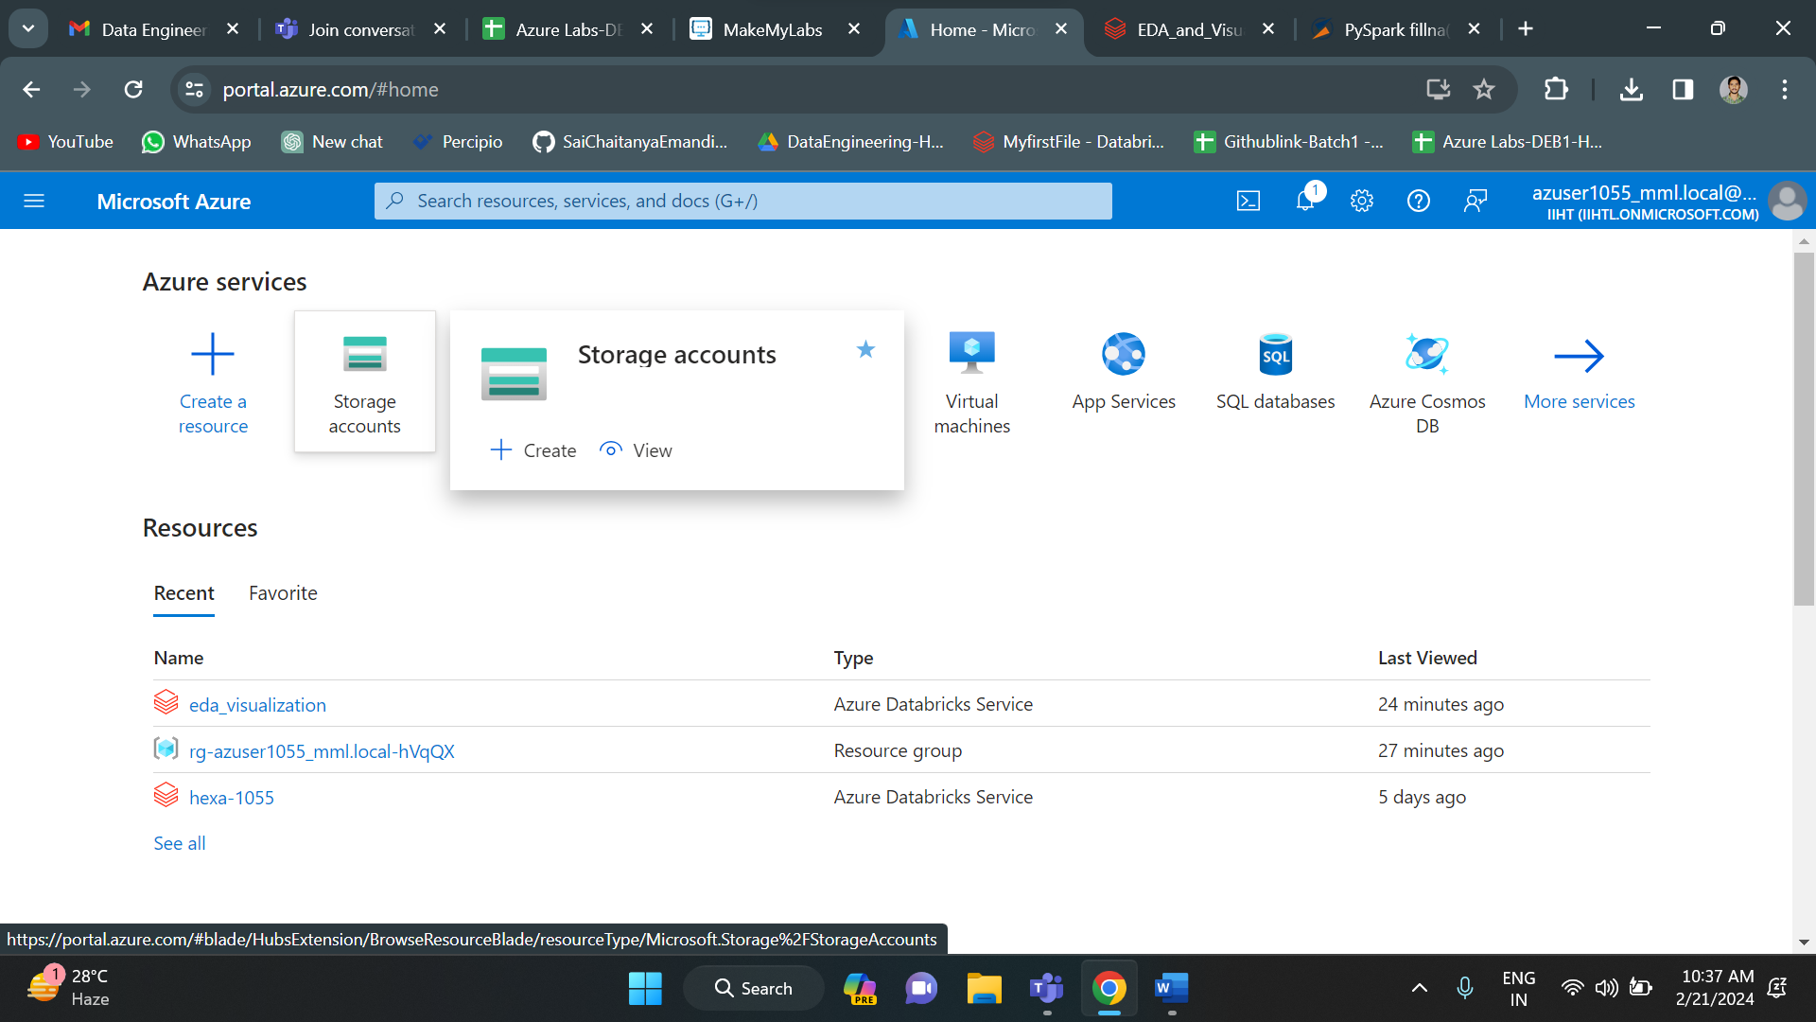

Now click on create to create a new storage account.

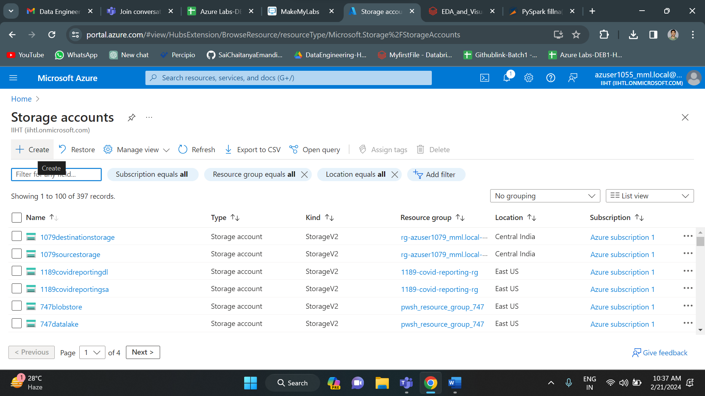

Fill all the required details and click on create-to-create new storage account. The name of the first storage account is “first1055”.

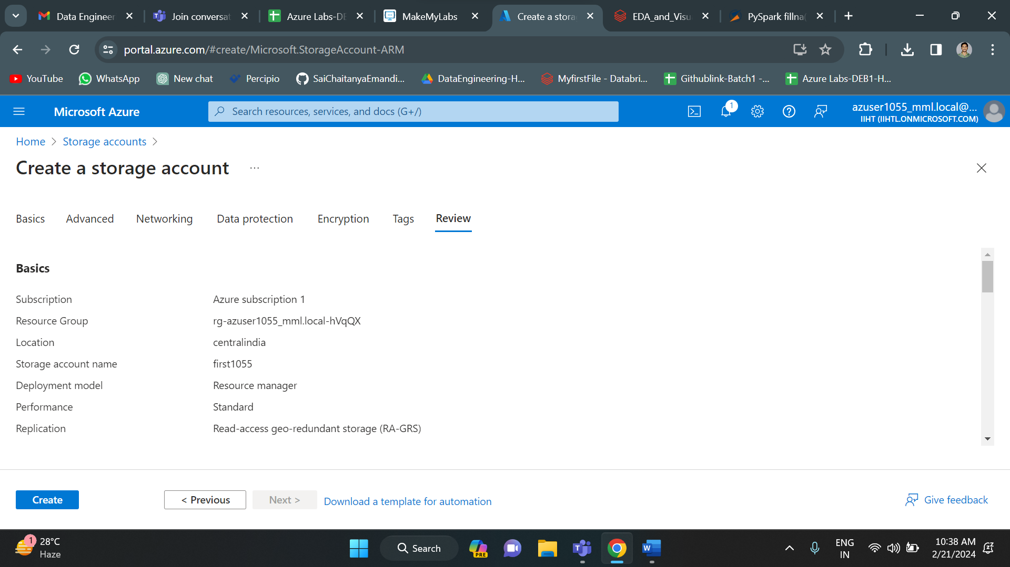

After clicking on create, your deployment gets initiated. Once your deployment gets completed click on go to resource.

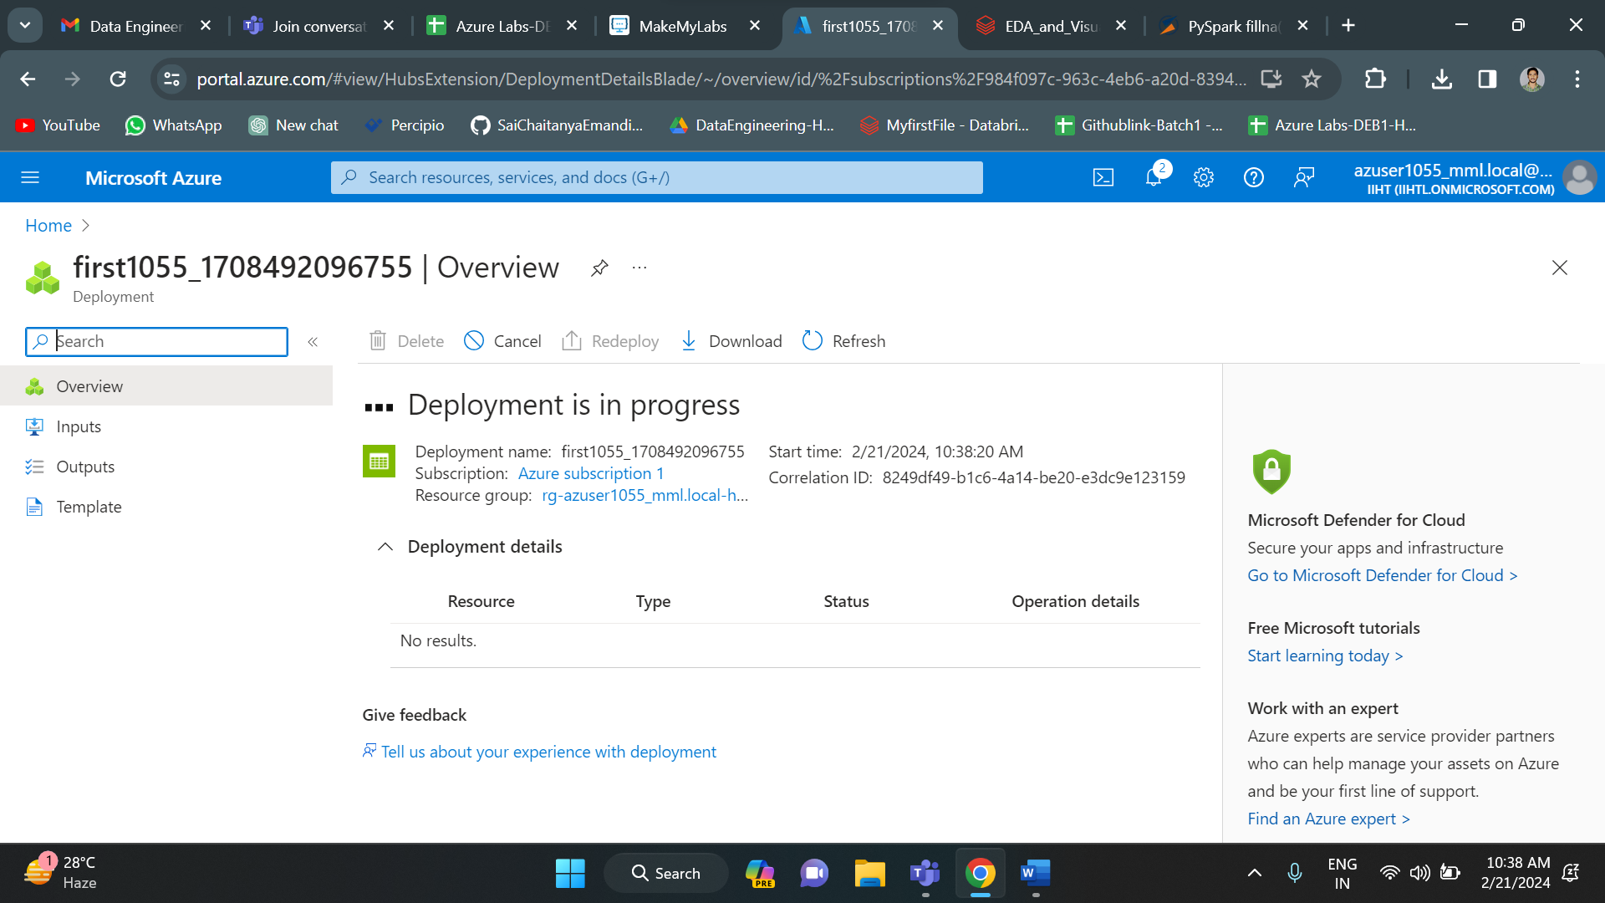

This is the overview of the first1055 storage account.

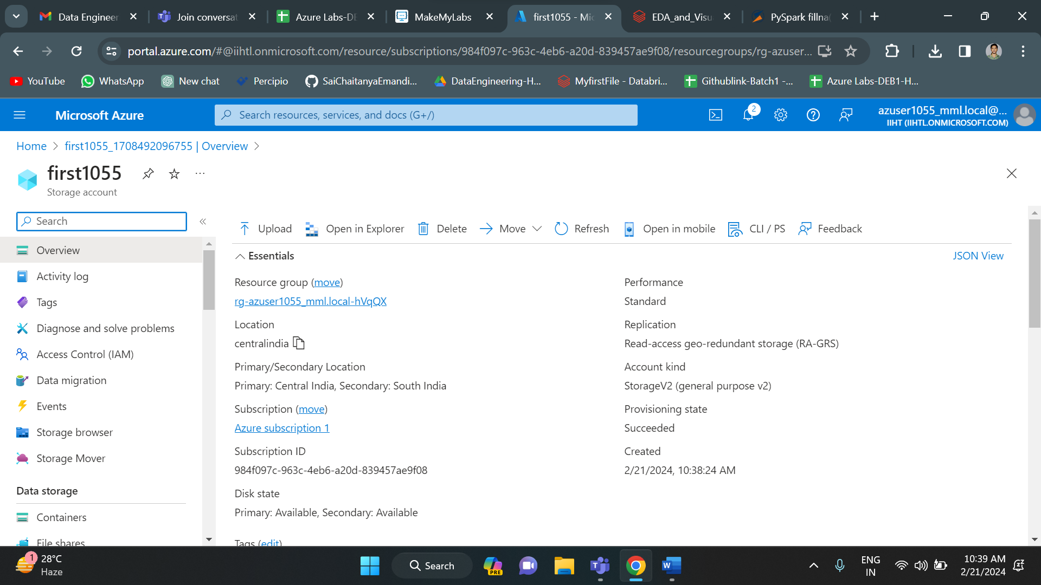

Now click on containers to create a new container. On top you can see the “+container” option. Click on that to create a new container.

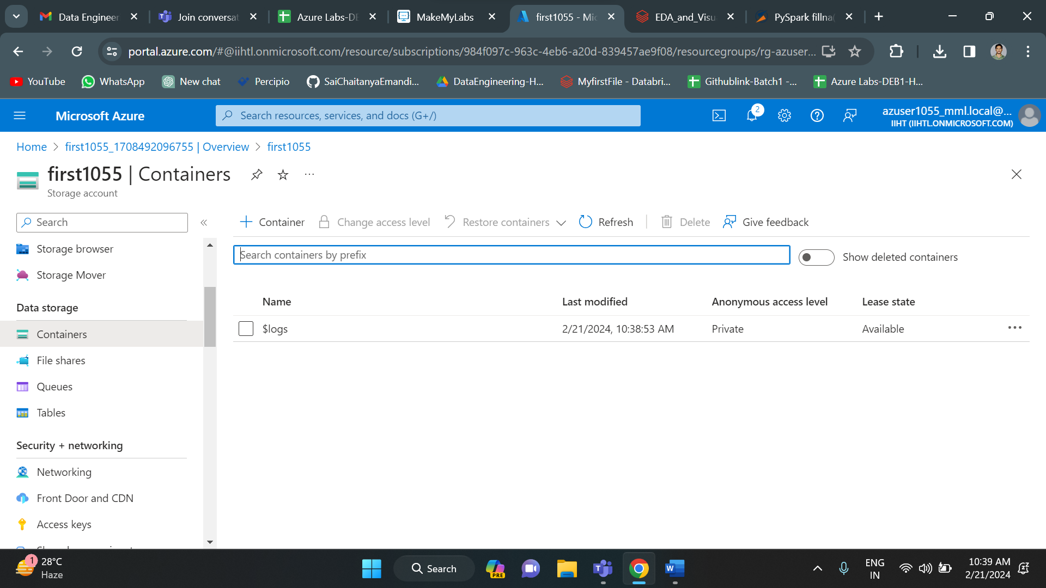

Give the container name and then click on create.

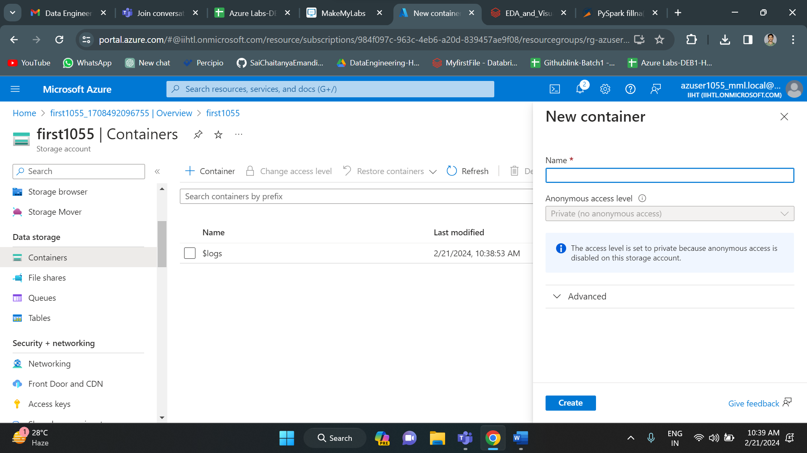

Your container got created. Now click on upload to upload a file into the container.

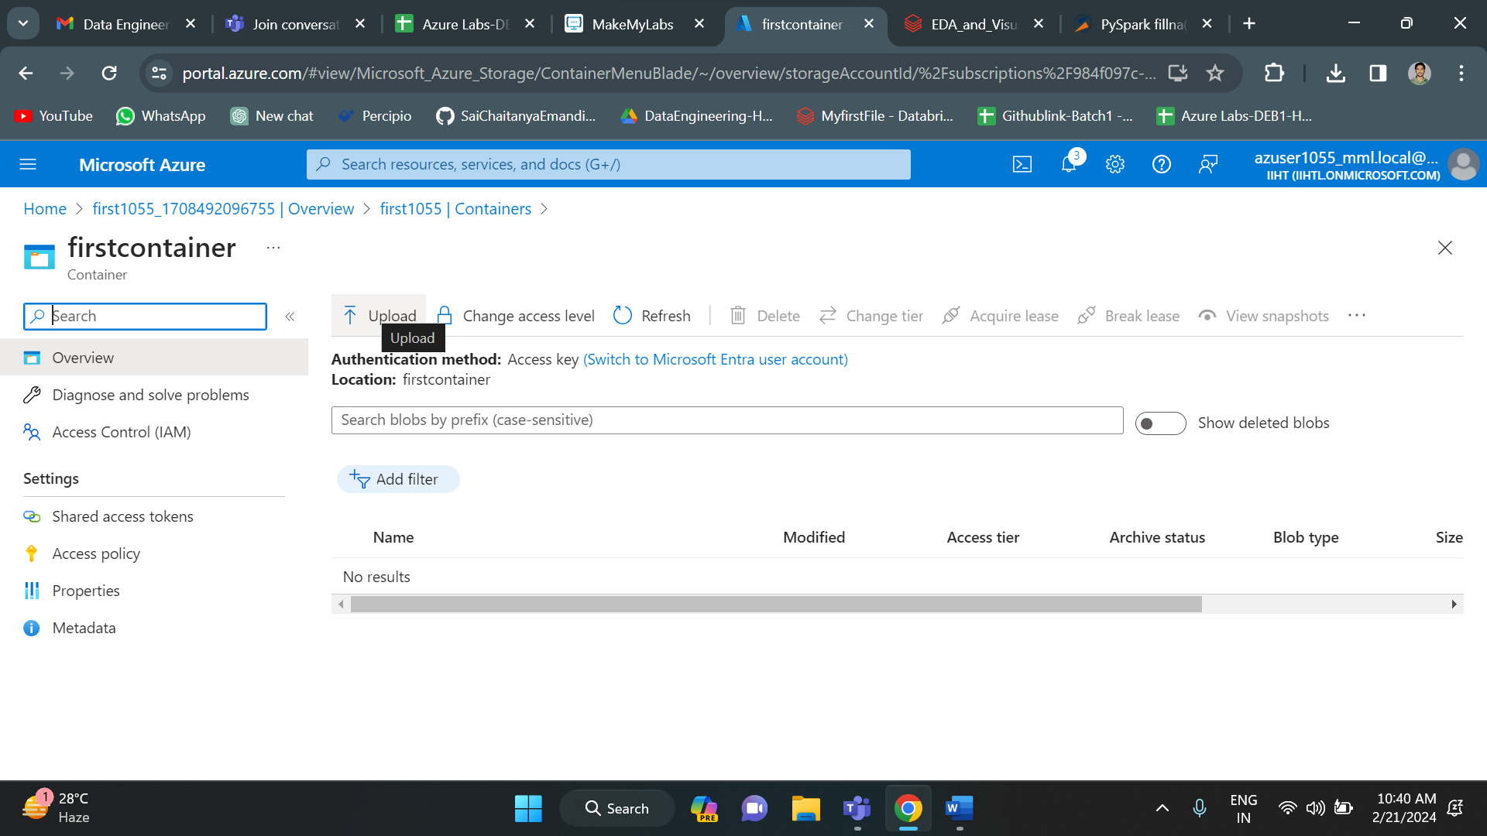

I have uploaded the “Departments.csv” file into the container of **“first1055”** storage account.

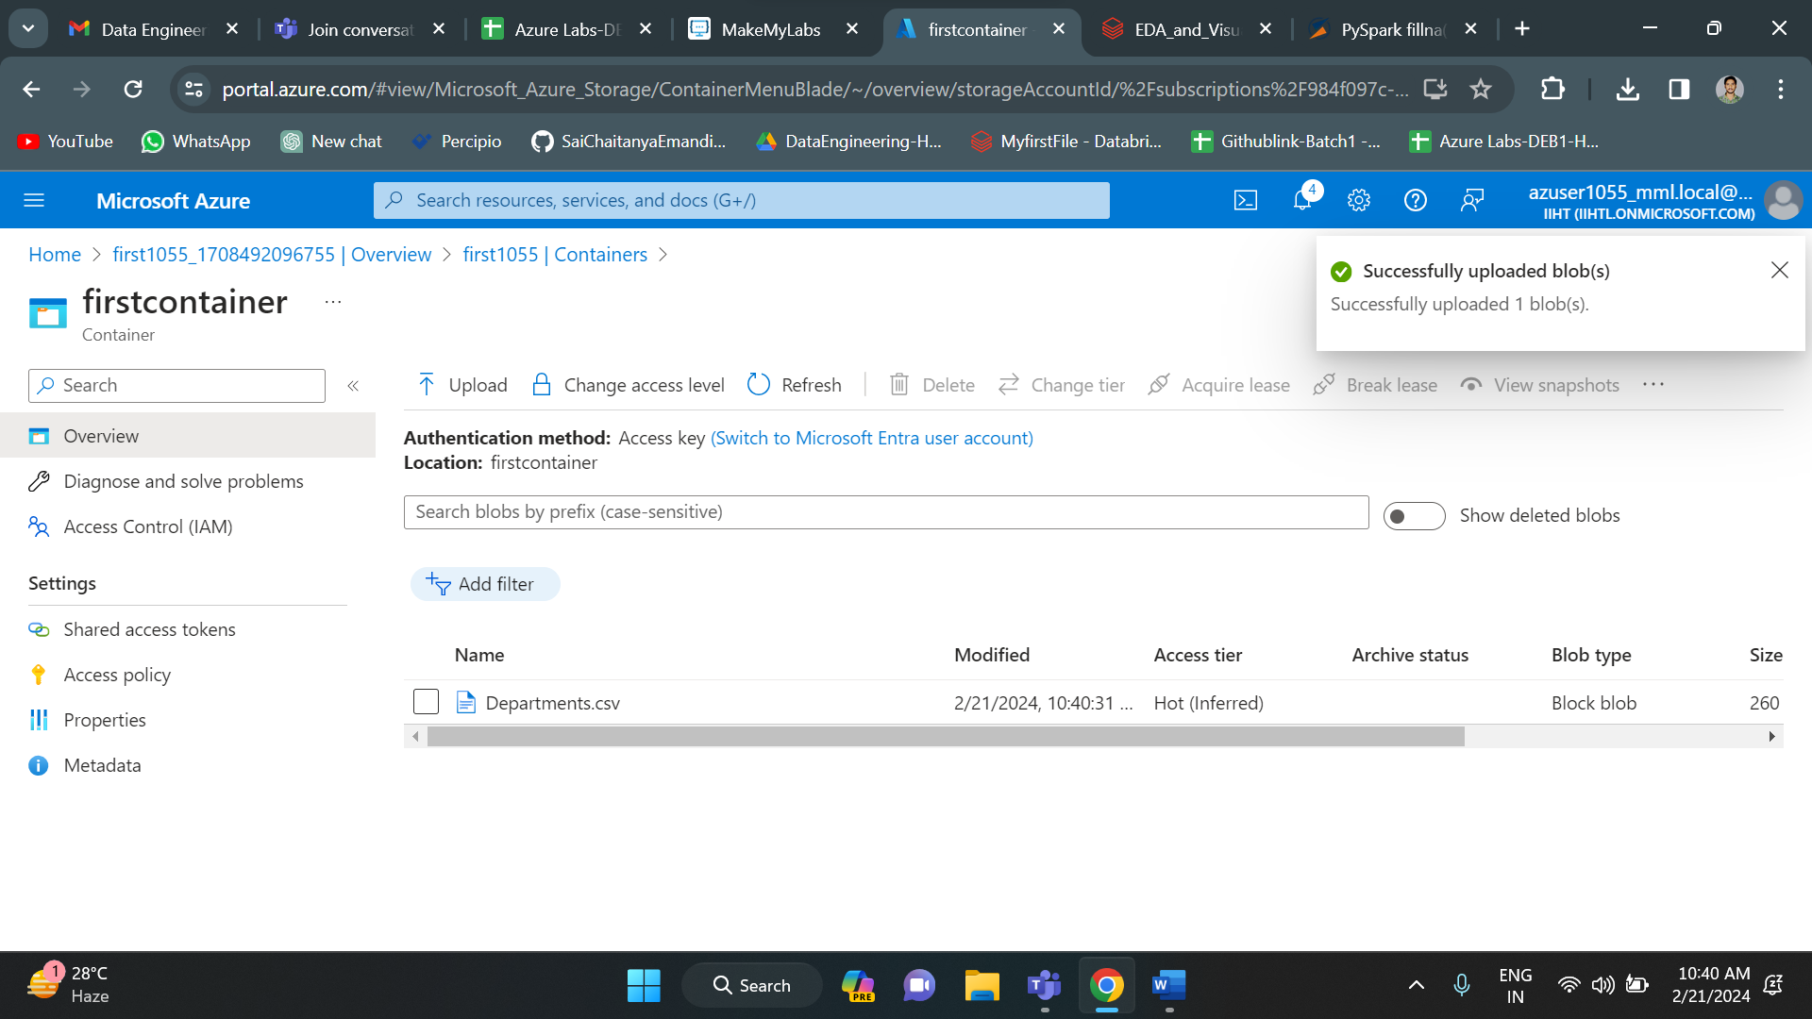

Similarly, I have created the second container with a name “second1055”. I have created a container in second storage account with name “secondcontainer”. Now my storage accounts are ready.

**COPY ACTIVITY BEGINS**

To begin the copy activity, first we should create a data factory. For this, in the azure home page click on data factories.

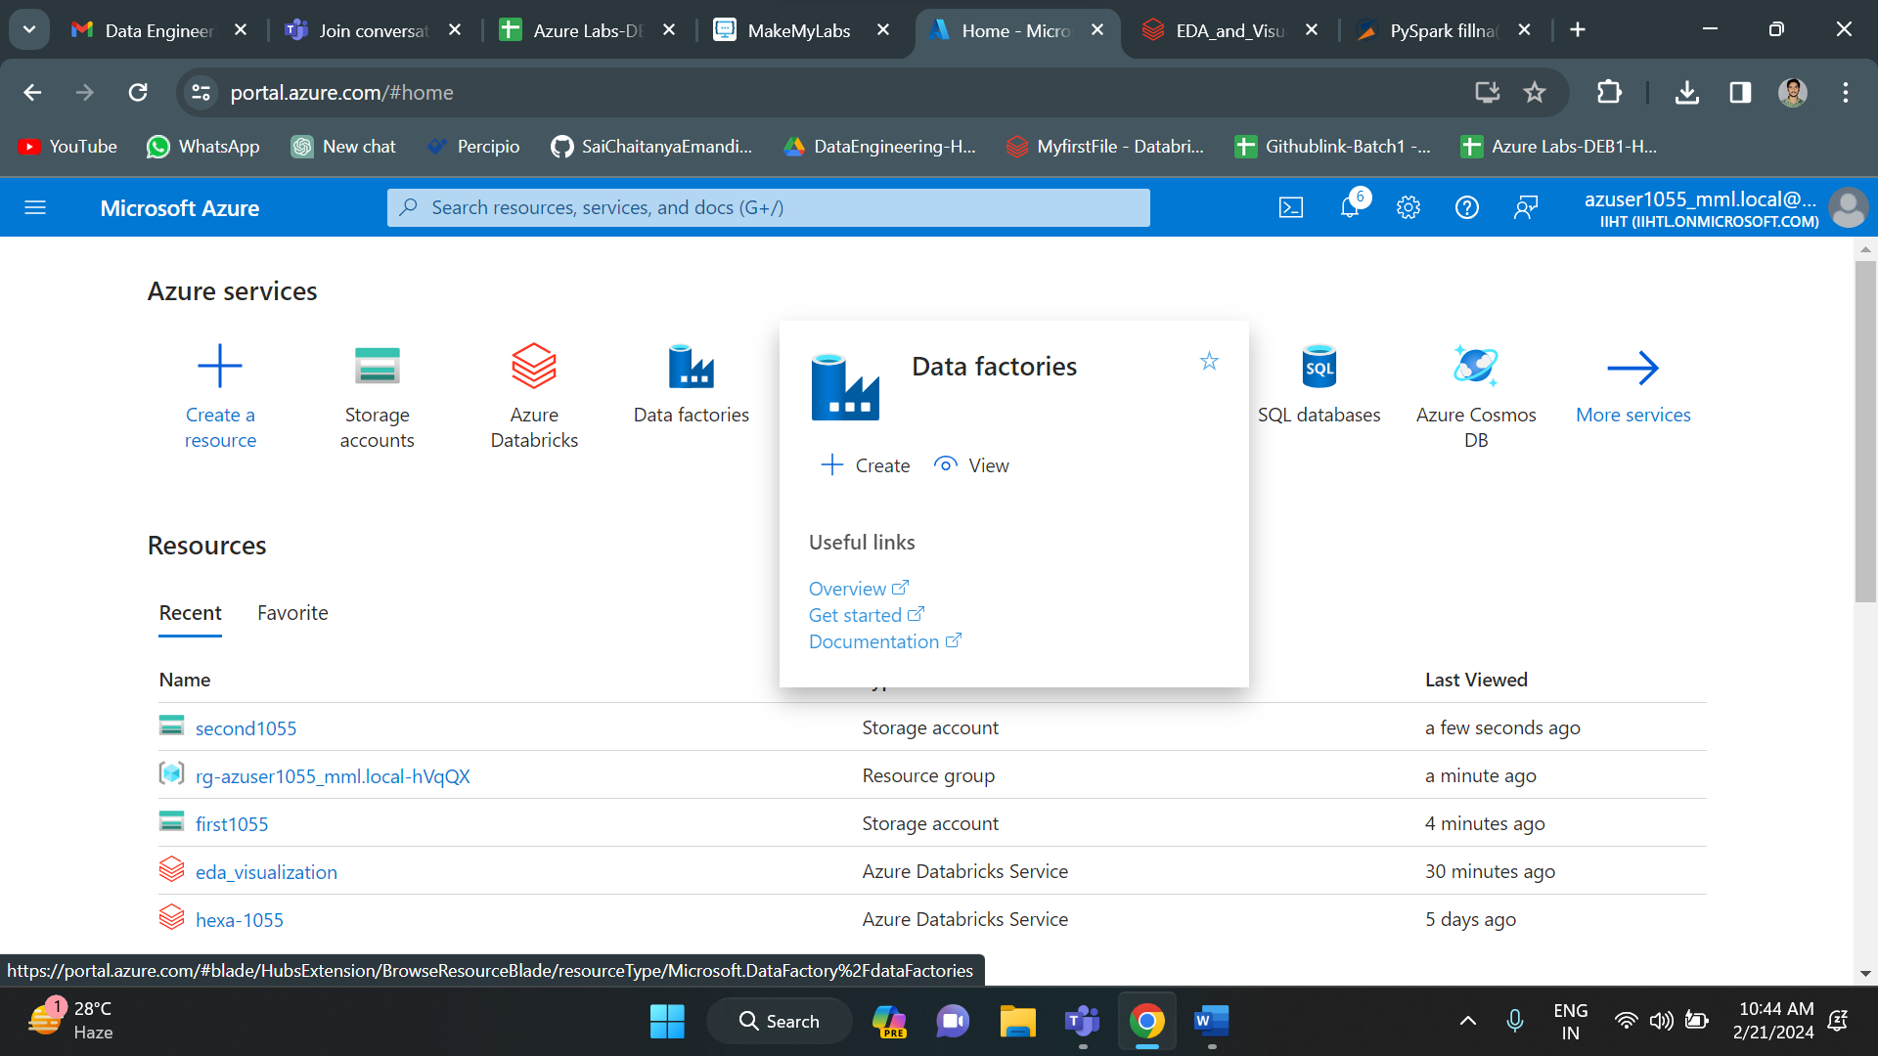

Click on create to create a new data factory.

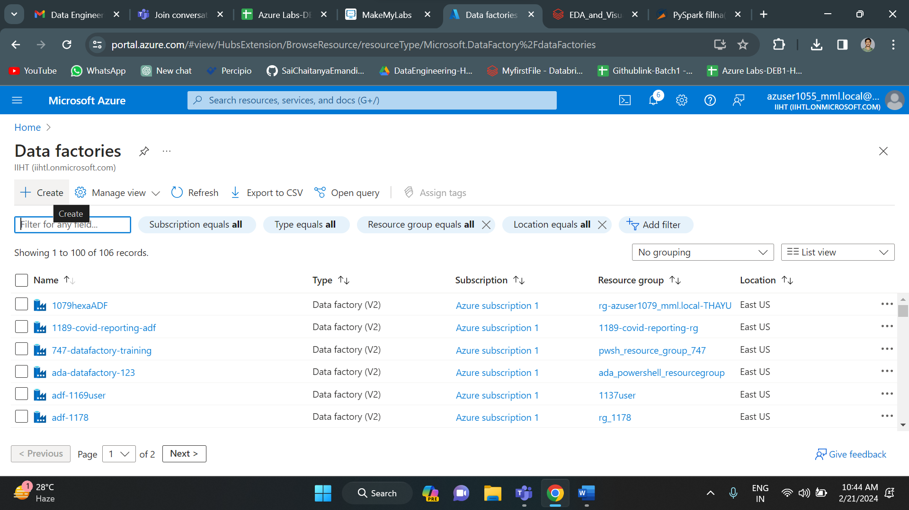

Fill all the details and click on create. Your deployment gets initiated.

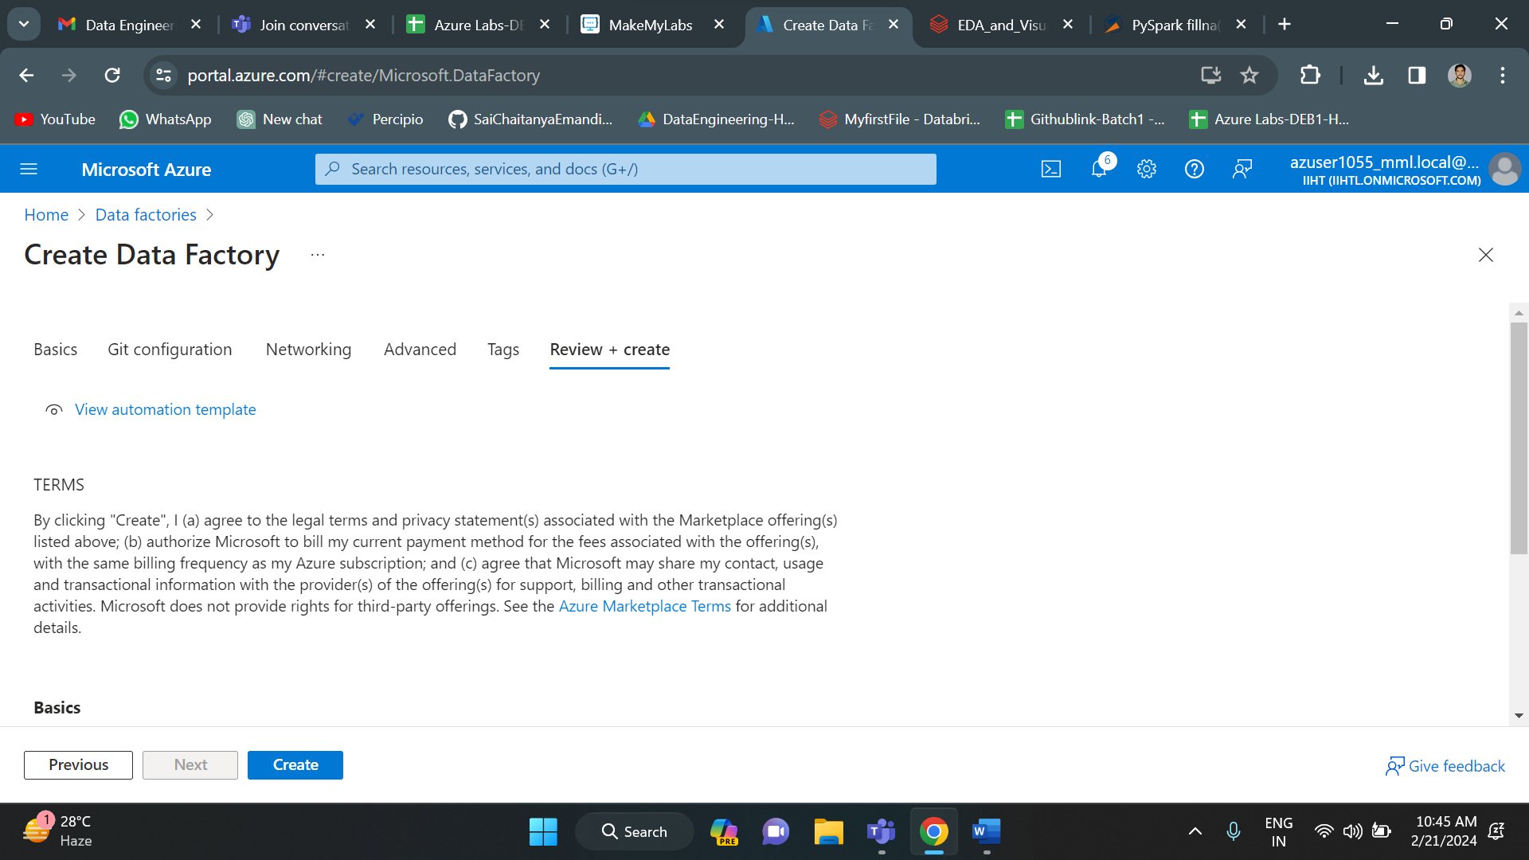

Azure data factory deployment is completed. Now click on launch studio to use the data factory.

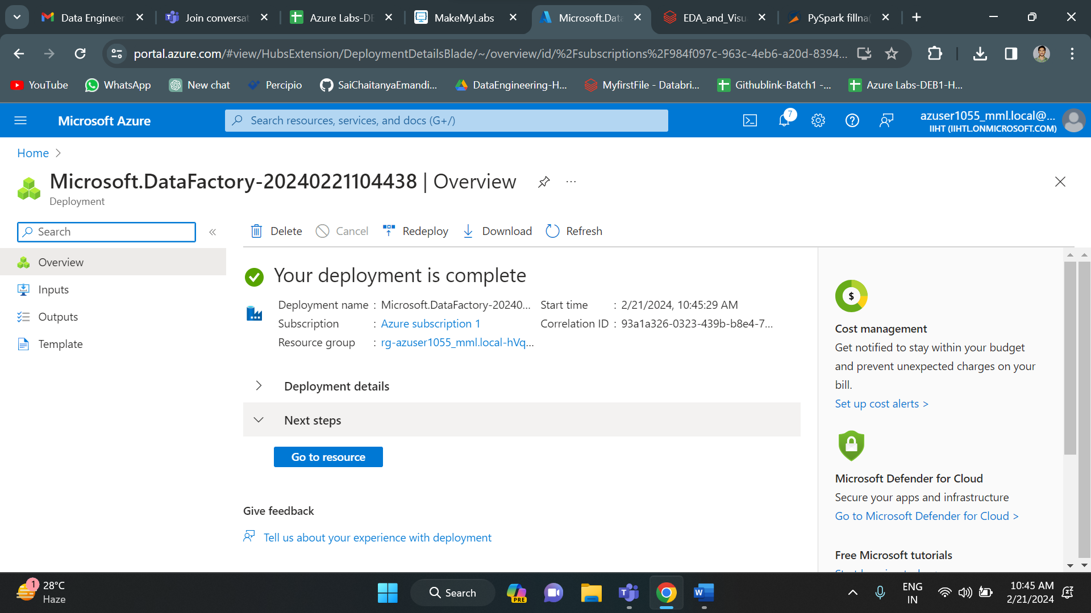

This is the overview of data factory.

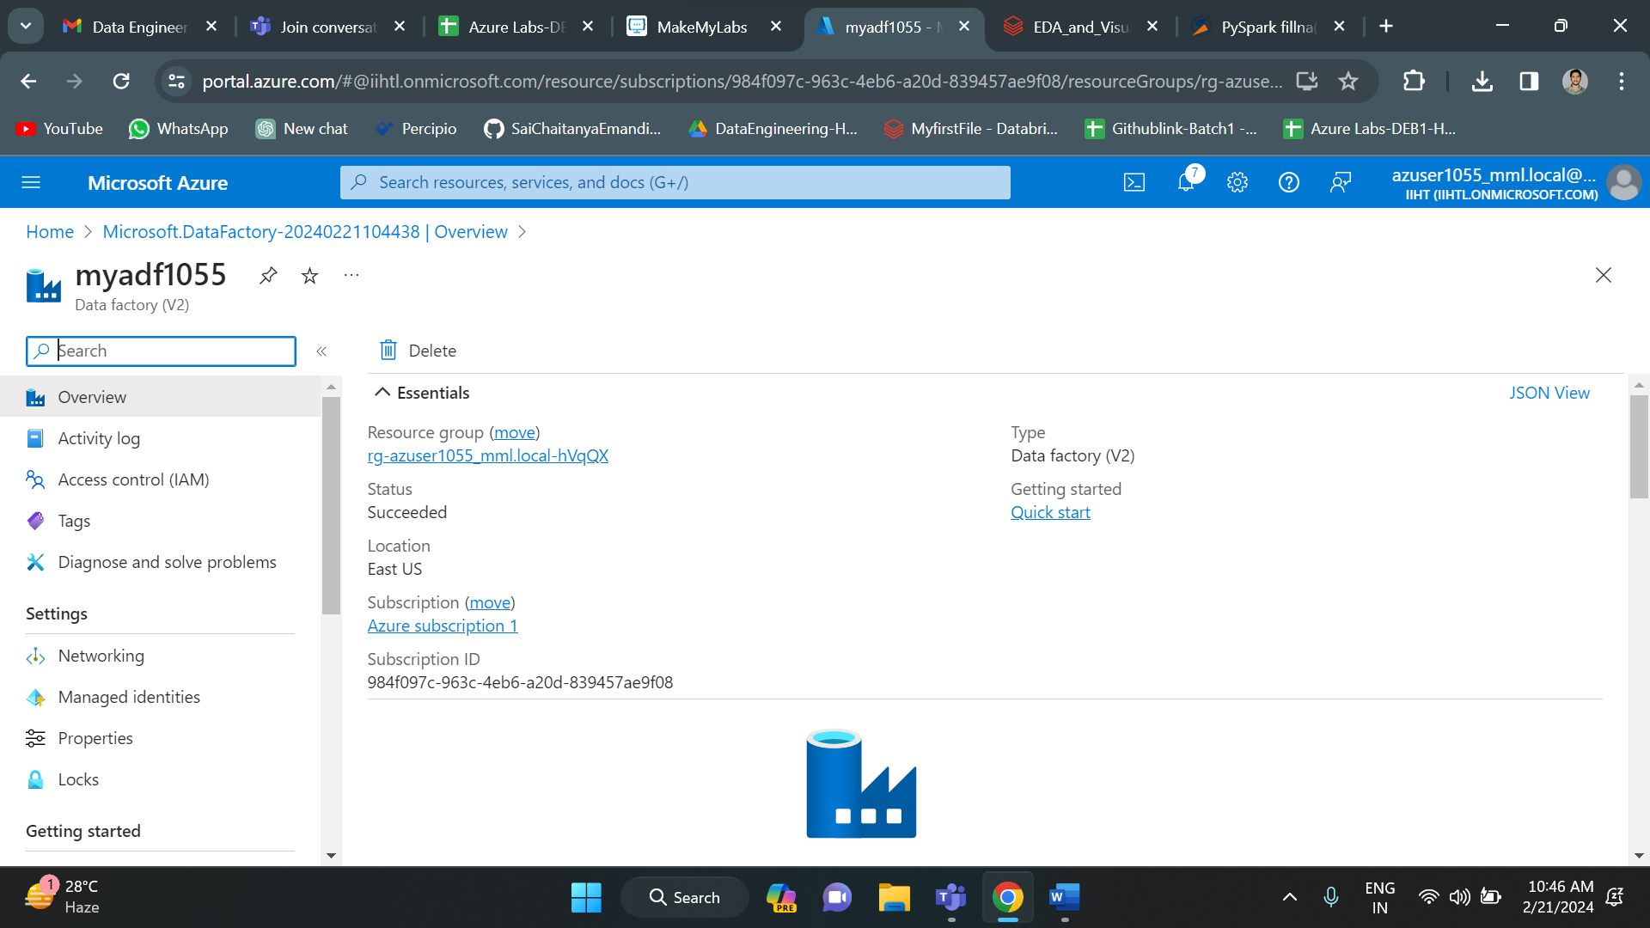

This is the home page of azure data factory. Click on ingest.

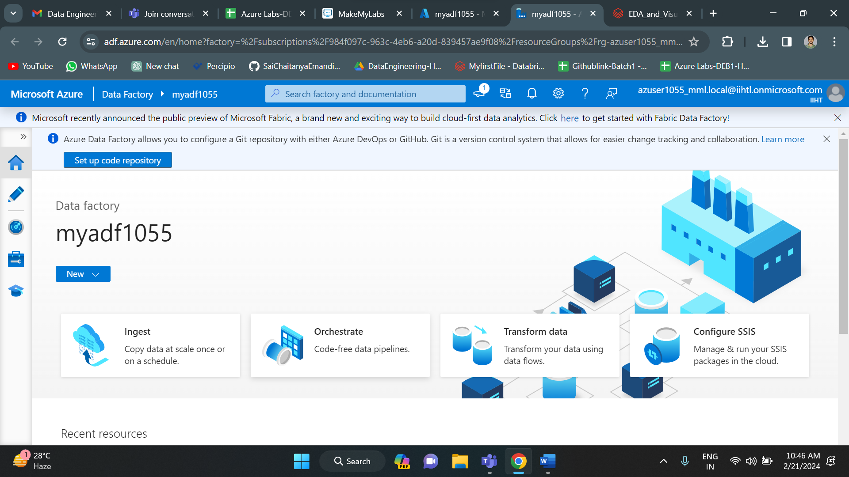

Select built in and click on next.

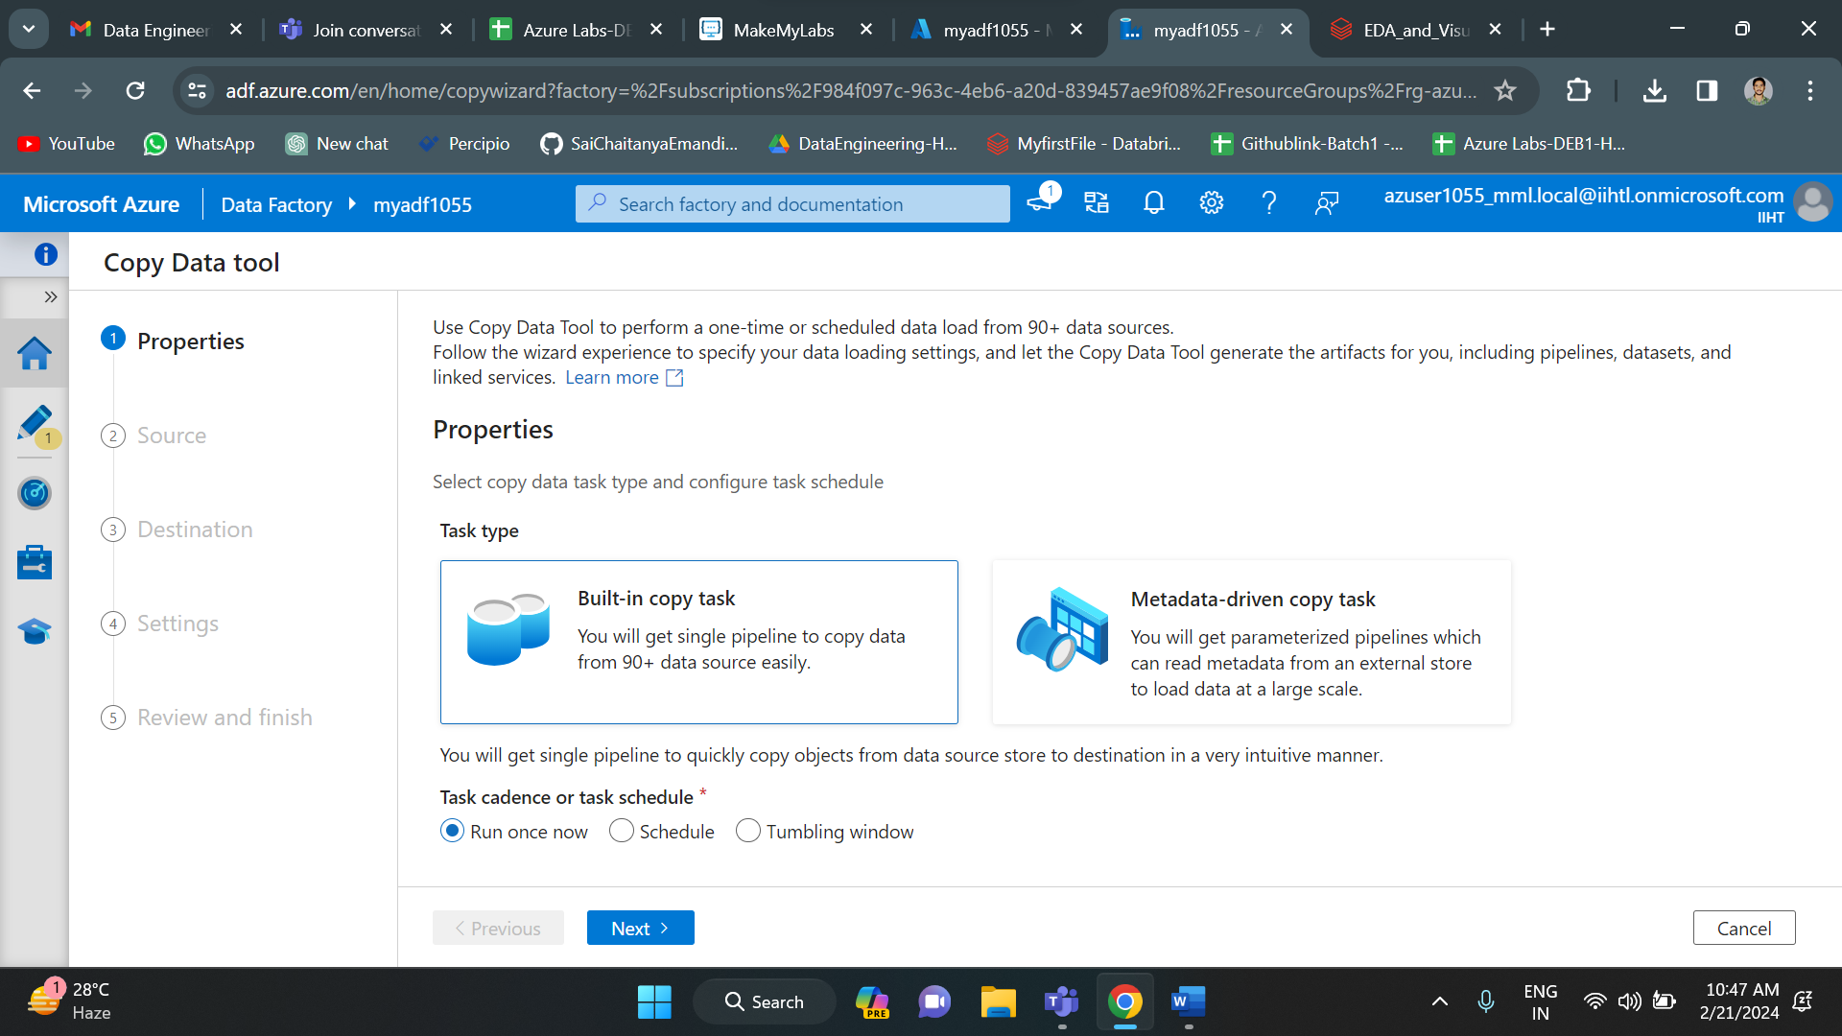

Give the source and destination configurations.

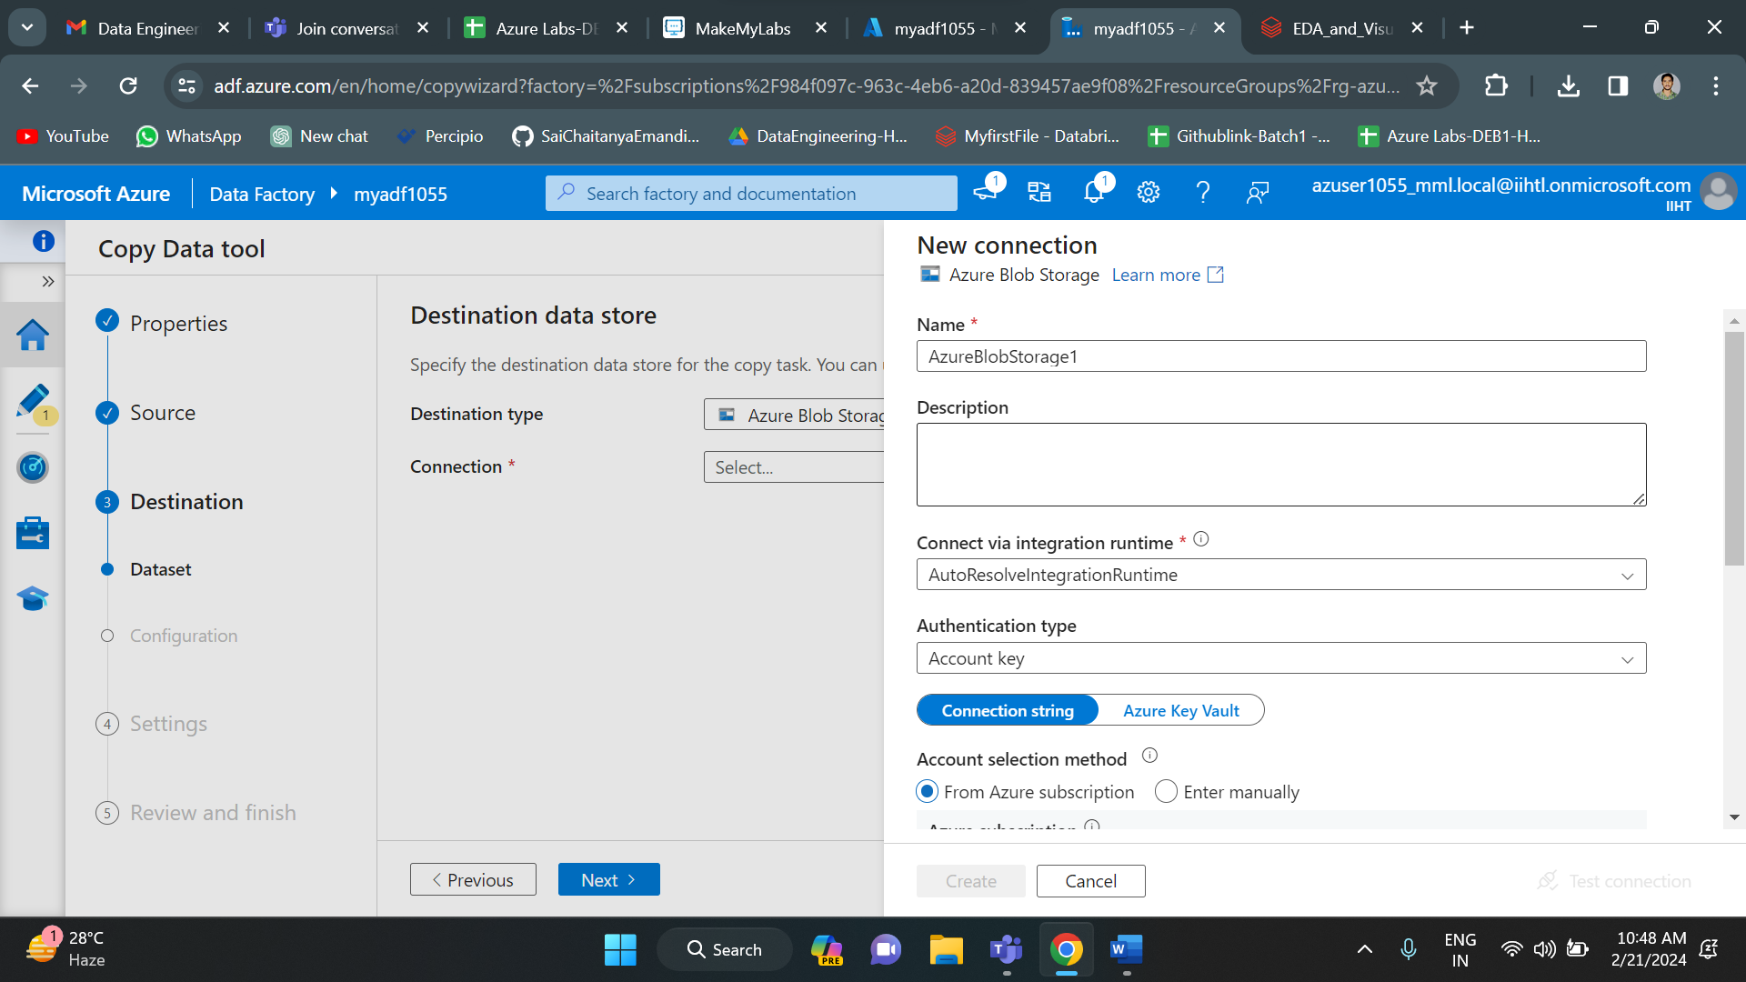

After all the steps, it shows the review. You can review all the above completed steps. Click next.

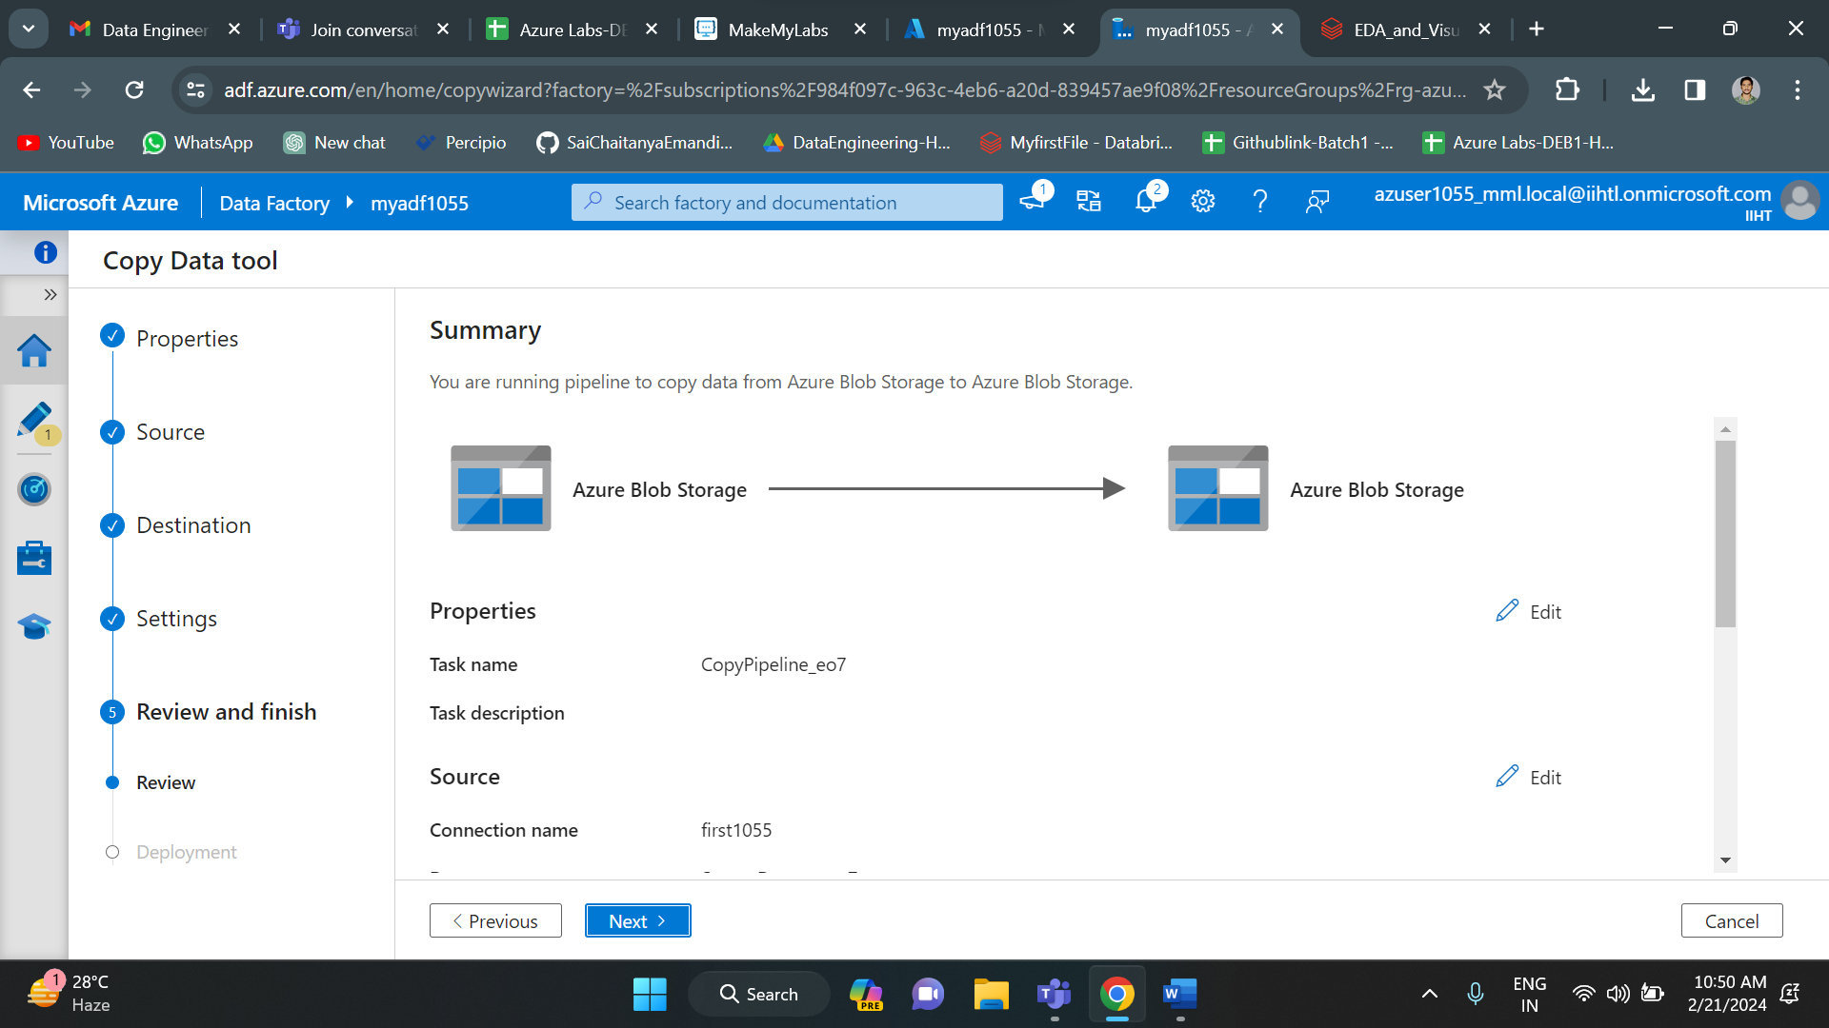

Since deployment is completed click on finish.

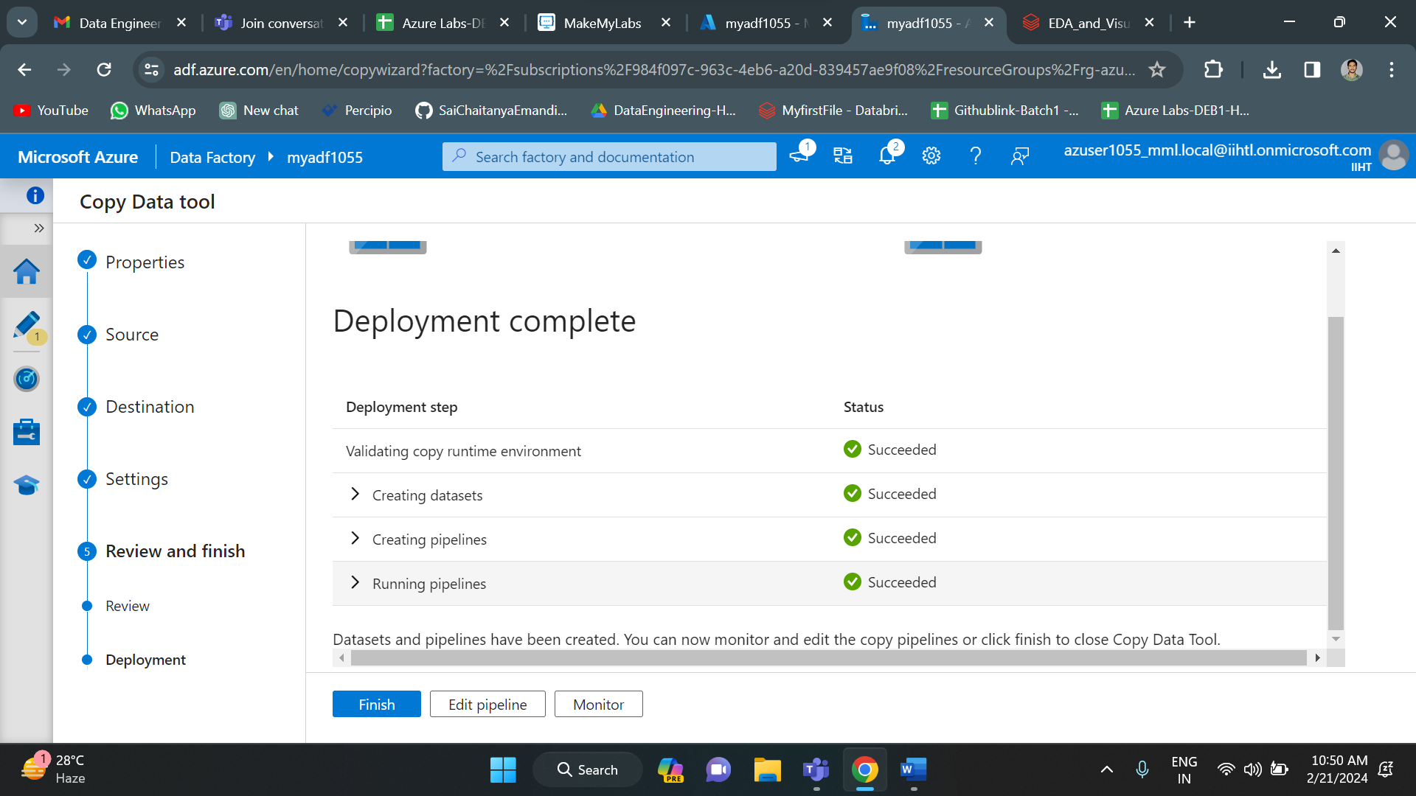

As you can see below, my copy activity is successfully completed.

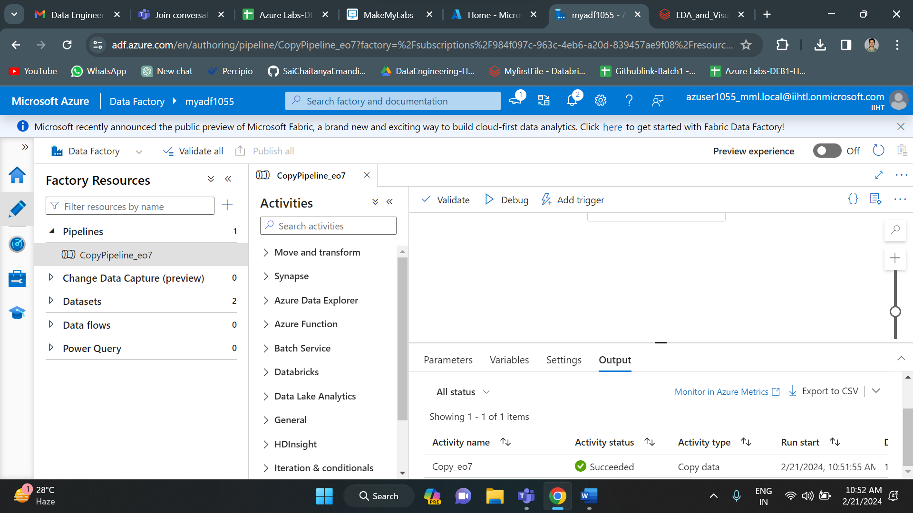

Now the departments.csv file which is “firstcontainer” of “first1055” storage account is now copied to the “secondcontainer” of “second1055” storage account. So the copy activity is successfull.

